**Experiment Title 2.1**

**Student Name: Sahul Kumar Parida UID: 20BCS4919**

**Branch: CSE Section/Group: WM-904/B**

**Semester: 5th**

**Subject Name: Project Based Learning using Java**

**Subject Code: 20CSP-321**

**1. Aim/Overview of the practical:**

Write a program to collect and store all the cards to assist the users in finding all the cards in a given symbol.

This cards game consists of N number of cards. Get N number of cards details from the user and store the values in Card object with the attributes symbol and number.

Store all the cards in a map with symbol as its key and list of cards as its value. Map is used here to easily group all the cards based on their symbol.

Once all the details are captured print all the distinct symbols in alphabetical order from the Map. For each symbol print all the card details, number of cards and their sum respectively.

**2. Software/Hardware Requirements:**

# Windows

# BlueJ (Java IDE)

# JRE (Java Runtime Environment)

**3. Steps for experiment/practical/Code:**

import java.util.*;

class Exp2_1

{

public static void main()

{

TreeMap<Character, ArrayList<Integer>> t= new TreeMap<Character,ArrayList<Integer> >();

System.out.println("Enter number of cards");

int n;

Scanner sc=new Scanner(System.in);

n=sc.nextInt();

for(int i=0;i<n;i++)

{

System.out.println("Enter card "+(i+1)+" :");

char c=sc.next().charAt(0);

int p=sc.nextInt();

ArrayList<Integer> cards = t.get(c);

if(cards == null)

{

cards = new ArrayList<Integer>();

cards.add(p);

t.put(c, cards);

}

else

{

cards.add(p);

t.put(c, cards);

}

}

Set<Character> cardkeys = t.keySet();

System.out.println("Distinct Symbols are");

System.out.println(cardkeys);

for (Character key : t.keySet())

{

System.out.println("Cards in " + key + " Symbol");

ArrayList<Integer> cards = t.get(key);

int sum=0;

for(int i=0;i<cards.size();i++)

{

sum=sum + cards.get(i);

System.out.println(key + " " + cards.get(i));

}

System.out.println("Number of cards: " + cards.size());

System.out.println("Sum of Numbers: " + sum);

}

}

}

**4. Result/Output/Writing Summary:**

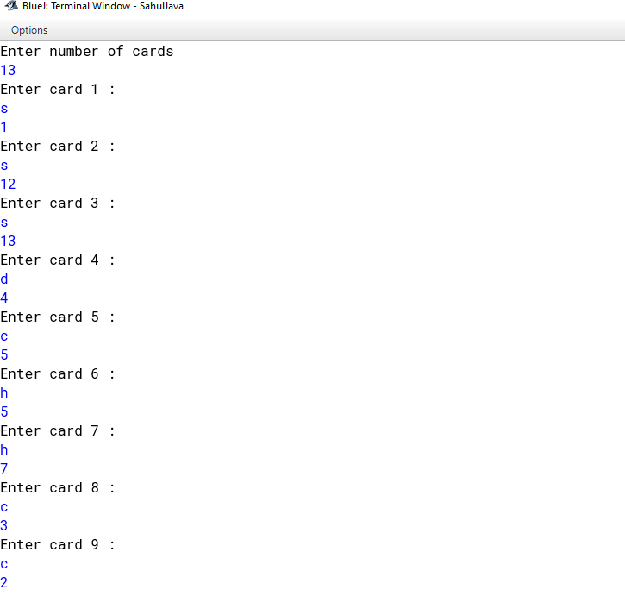

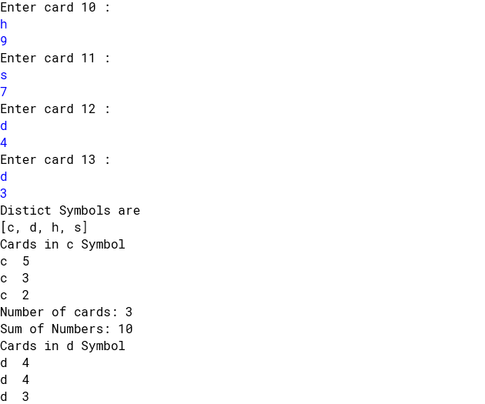

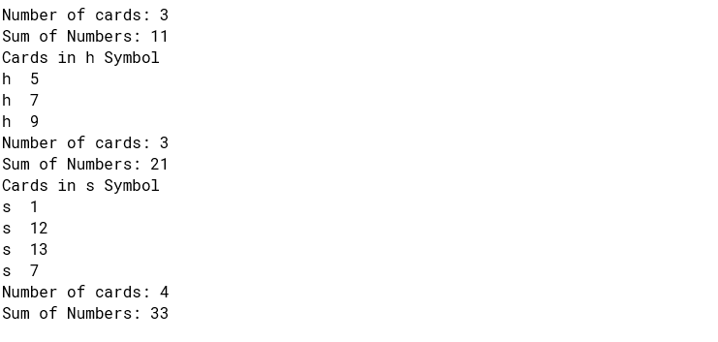

**Learning outcomes (What I have learnt):**

**1. Character Set**

**2. Data Structures**

**3. TreeMap**

**4. ArrayList**